PANDUAN LENGKAP BERGAMBAR: PEMASANGAN & PENGGUNAAN VEYON
Sistem Pemantauan Skrin Komputer Murid di Makmal Komputer Sekolah
Veyon 4.11.3 | SK Dataran Muda | Disediakan untuk Guru & Rakan Sejawat

Pengenalan Ringkas:
Veyon (Virtual Eye On Networks) ialah perisian pemantauan bilik darjah sumber terbuka yang membolehkan guru melihat skrin murid secara langsung (real-time), mengunci skrin murid ketika guru sedang menerangkan pelajaran, membuat siaran skrin guru (Demo), dan menghantar mesej teks terus ke komputer murid. Panduan ini mendokumentasikan 26 langkah persediaan lengkap dari A hingga Z.
Aspek / Komponen | Komputer Guru (Master) | Komputer Murid (Client)
Peranan Utama | Pusat Kawalan & Pemantauan (Master) | Komputer Sasaran / Paparan Murid
Komponen Dipasang | Veyon Service, Veyon Master, Driver | Veyon Service, Driver (Master DINYAH-TANDA)
Kunci Keselamatan | Memegang Private Key & Public Key (LAB) | Hanya memegang Public Key (LAB_public_key.pem)
Antara Muka (Tema) | Tema Gelap / Dark Mode (Aksen Ungu) | Tema Cerah / Light Mode (Aksen Biru)
Firewall Windows | Tetapan Asal / Dibenarkan | Wajib jalankan firewall.bat (Port 11100-11400)

PHASE 1: TEACHER MASTER SETUP & KEY GENERATION
Lokasi / Stesen: TEACHER PC (GURU) | Tema: Dark Theme (Purple)

Langkah 1: Download Required Setup Files from tr.ee/aJwAd
Open your web browser and navigate to tr.ee/aJwAd (or open the shared Google Drive folder). Download the two mandatory deployment files to your Downloads folder: veyon-4.11.3.0-win64-setup.exe (16 MB) and firewall.bat (1 KB).
💡 TIP TEKNIKAL: Save both files in your primary Downloads folder. You will use these for both your Teacher PC installation and distribution to student devices.

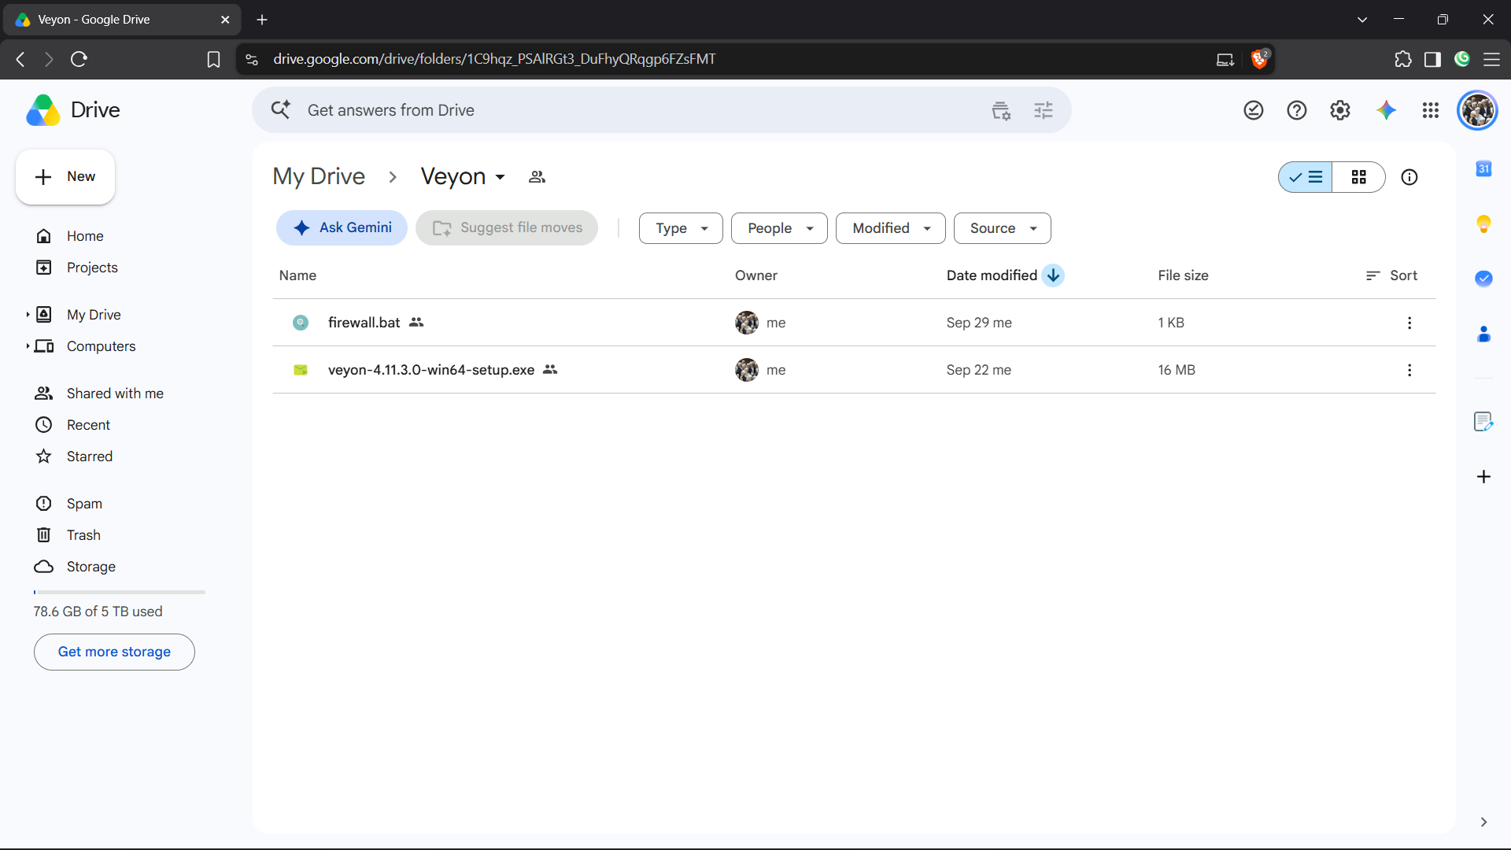
Rajah 1: download files from this folder by going to tr.ee slash aJwAd.png
Langkah 2: Run Installer & Check ALL Components (Master Included)
Double-click veyon-4.11.3.0-win64-setup.exe on the Teacher PC. Accept the license agreement. When you reach the 'Choose Components' window, make sure ALL THREE components are checked:
• [✓] Veyon Service
• [✓] Veyon Master (CRITICAL: Must be checked on Teacher PC)
• [✓] Interception driver
Then click Install.
💡 TIP TEKNIKAL: The Veyon Master component is the teacher's command console used to view, remote-control, and lock student screens.

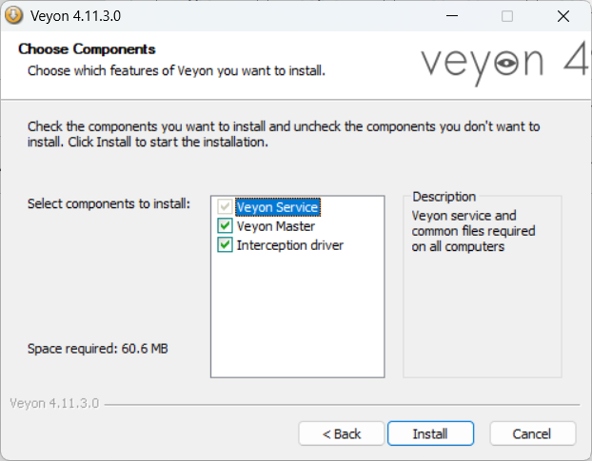
Rajah 2: make sure everything is checked and click install.png
Langkah 3: Complete Setup & Launch Veyon Configurator
Once the setup finishes copying files, the 'Completing Veyon Setup' window will appear. Ensure the checkbox '[✓] Run Veyon Configurator now' is checked, then click Finish.
💡 TIP TEKNIKAL: If the Configurator does not launch automatically, search for 'Veyon Configurator' in your Windows Start Menu and open it.

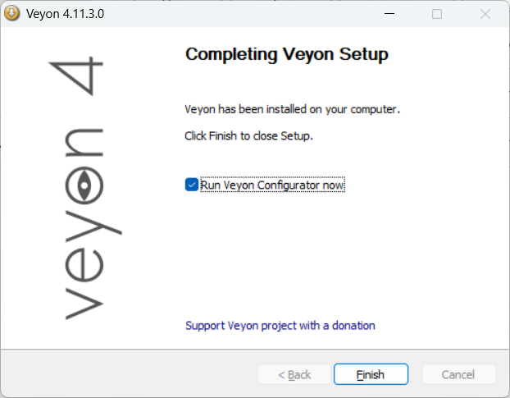
Rajah 3: click finish to run veyon configurator.png
Langkah 4: Set Authentication Method & Network Object Directory
In Veyon Configurator, select the 'General' tab from the left sidebar.
1. Under 'Authentication', set Method to: 'Key file authentication'.
2. Under 'Network object directory', set Backend to: 'Builtin (computers and locations in local configuration)'.
💡 TIP TEKNIKAL: Key file authentication uses cryptographic public-private key pairs so only your teacher laptop can control classroom screens. The Builtin directory stores computer names and IPs locally without requiring an LDAP server.

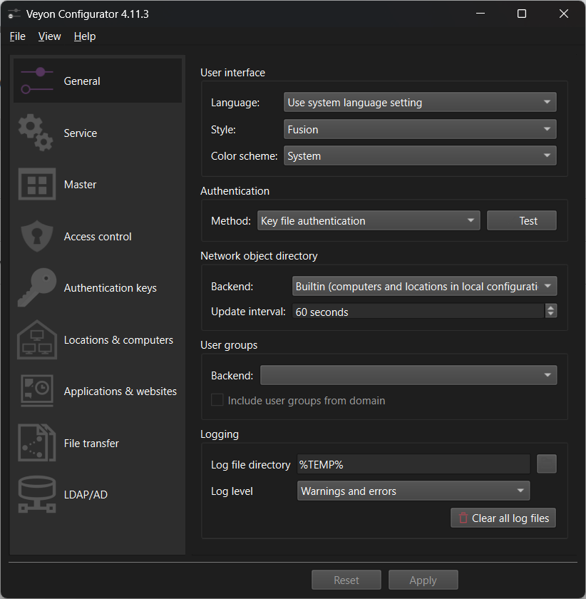
Rajah 4: auth method is key and builtin backend.png
Langkah 5: Set Service Session Mode to Active & Apply
Click the 'Service' tab (gear icon) in the left sidebar.
1. Verify that 'State' shows Running.
2. Under 'Session mode', select the second radio button: 'Active session mode (single server instance for active local or remote session)'.
3. Click Apply at the bottom.
💡 TIP TEKNIKAL: 'Active session mode' ensures Veyon captures whatever desktop session is actively logged in on the screen, whether local student user or domain account.

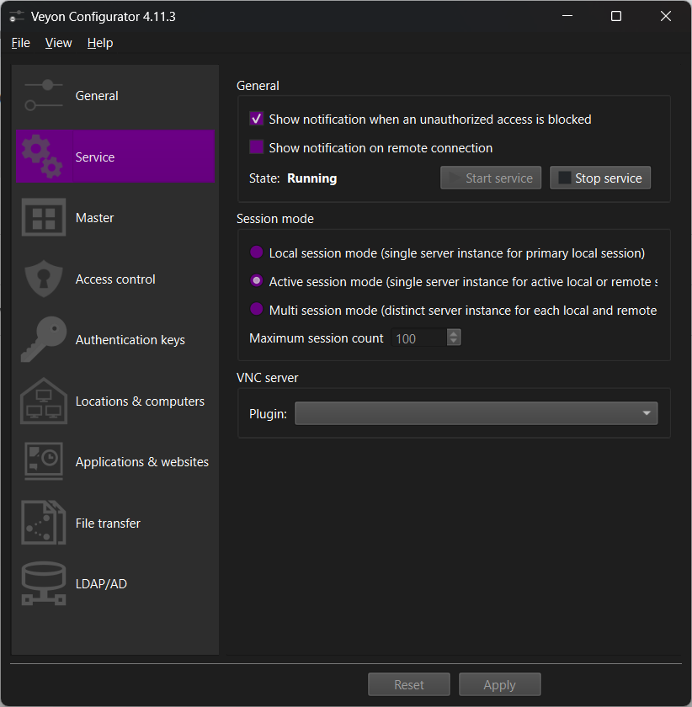
Rajah 5: set session mode to active.png
Langkah 6: Create Teacher Authentication Key Pair (LAB)
Click the 'Authentication keys' tab (key icon) in the left sidebar.
1. Click the 'Create key pair' button on the right.
2. Enter a name for your key pair, such as 'LAB' (or your school lab name).
3. Click OK. Veyon generates two keys: LAB (private) and LAB (public).
💡 TIP TEKNIKAL: The private key stays strictly on your Teacher laptop. The public key will be exported and given to student laptops.

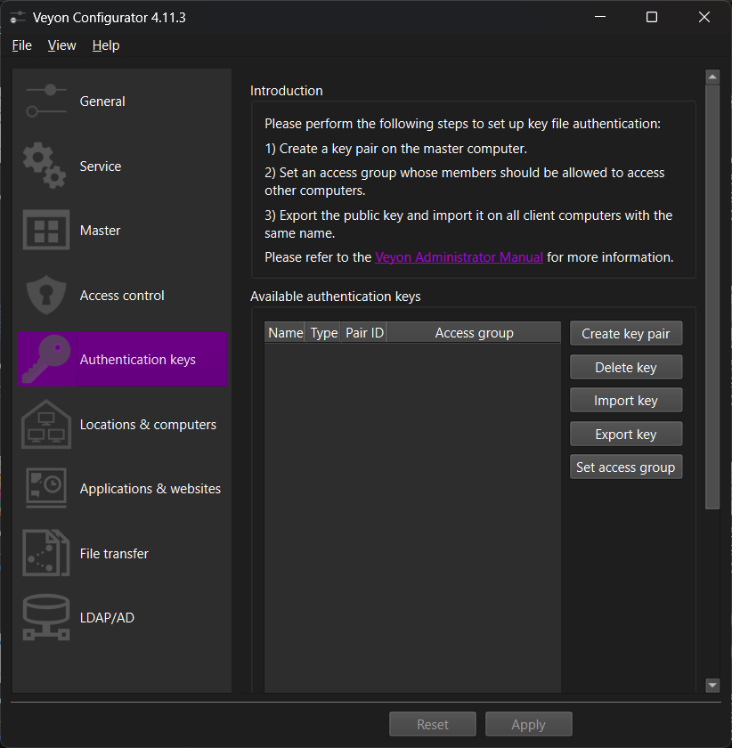
Rajah 6: click create pair key.png
Langkah 7: Export Public Key (LAB_public_key.pem)
In the key list, click on 'LAB (public)' to highlight it.
1. Click the 'Export key' button on the right.
2. Save the file with the default name 'LAB_public_key.pem' into your Downloads folder.
3. Click Save.
SECURITY WARNING: Never export or share your Private key! Only export the Public key (*.pem). Sharing the private key allows unauthorized laptops to monitor your lab.

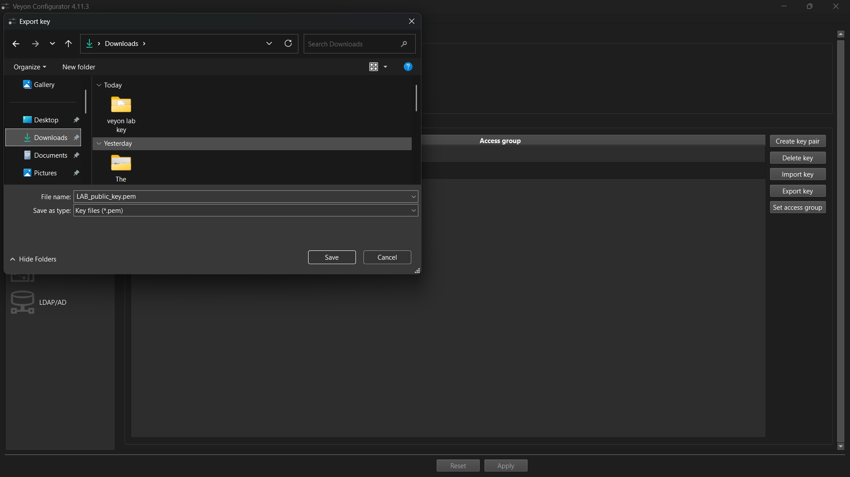
Rajah 7: export public key somewhere easily accessible.png
Langkah 8: Upload Deployment Package to SpeedyShare (Browser P2P)
Open your web browser and go to speedyshare.app.
1. Drag and drop or upload all THREE deployment files:
a. veyon-4.11.3.0-win64-setup.exe
b. LAB_public_key.pem
c. firewall.bat
2. Note the 6-digit Share Code (e.g. 257575) and QR Code generated on screen.
CRITICAL RULE: DO NOT CLOSE OR REFRESH THIS BROWSER TAB! SpeedyShare creates a live peer-to-peer room. If you close the tab or lock your laptop, students will not be able to connect or download files.

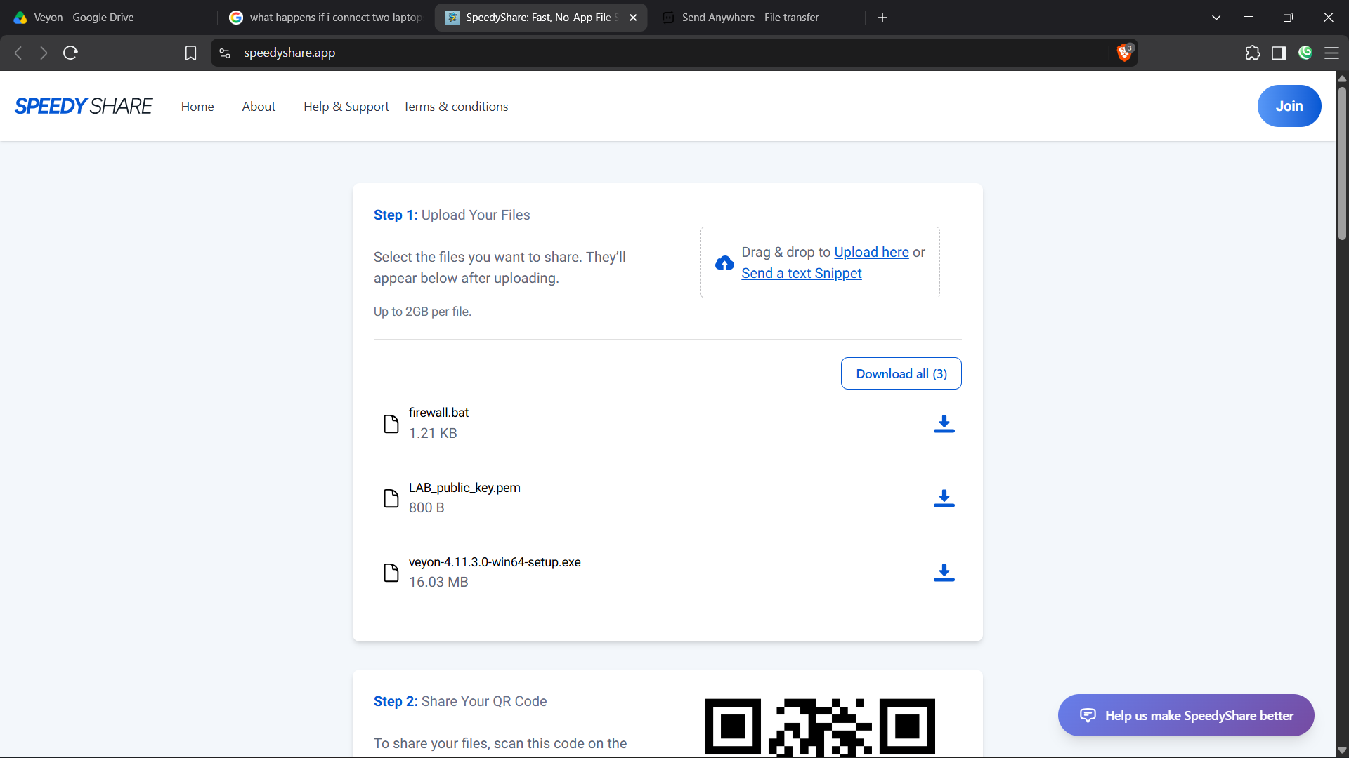
Rajah 8: open speedyshare app and upload google drive files and your public key here.png

PHASE 2: STUDENT LAPTOP CLIENT DEPLOYMENT & CONFIGURATION
Lokasi / Stesen: STUDENT LAPTOP (MURID) | Tema: Light Theme (Blue)

Langkah 9: On Student Laptop: Open SpeedyShare & Click Join
Sit at the student laptop (e.g. Computer 17). Ensure it is connected to the same Wi-Fi network as the teacher.
1. Open Google Chrome or Microsoft Edge.
2. Navigate to speedyshare.app.
3. Click the blue 'Join' button in the top right corner.
💡 TIP TEKNIKAL: Using SpeedyShare avoids having to insert USB thumb drives into 30 different laptops, saving over an hour of physical setup time.

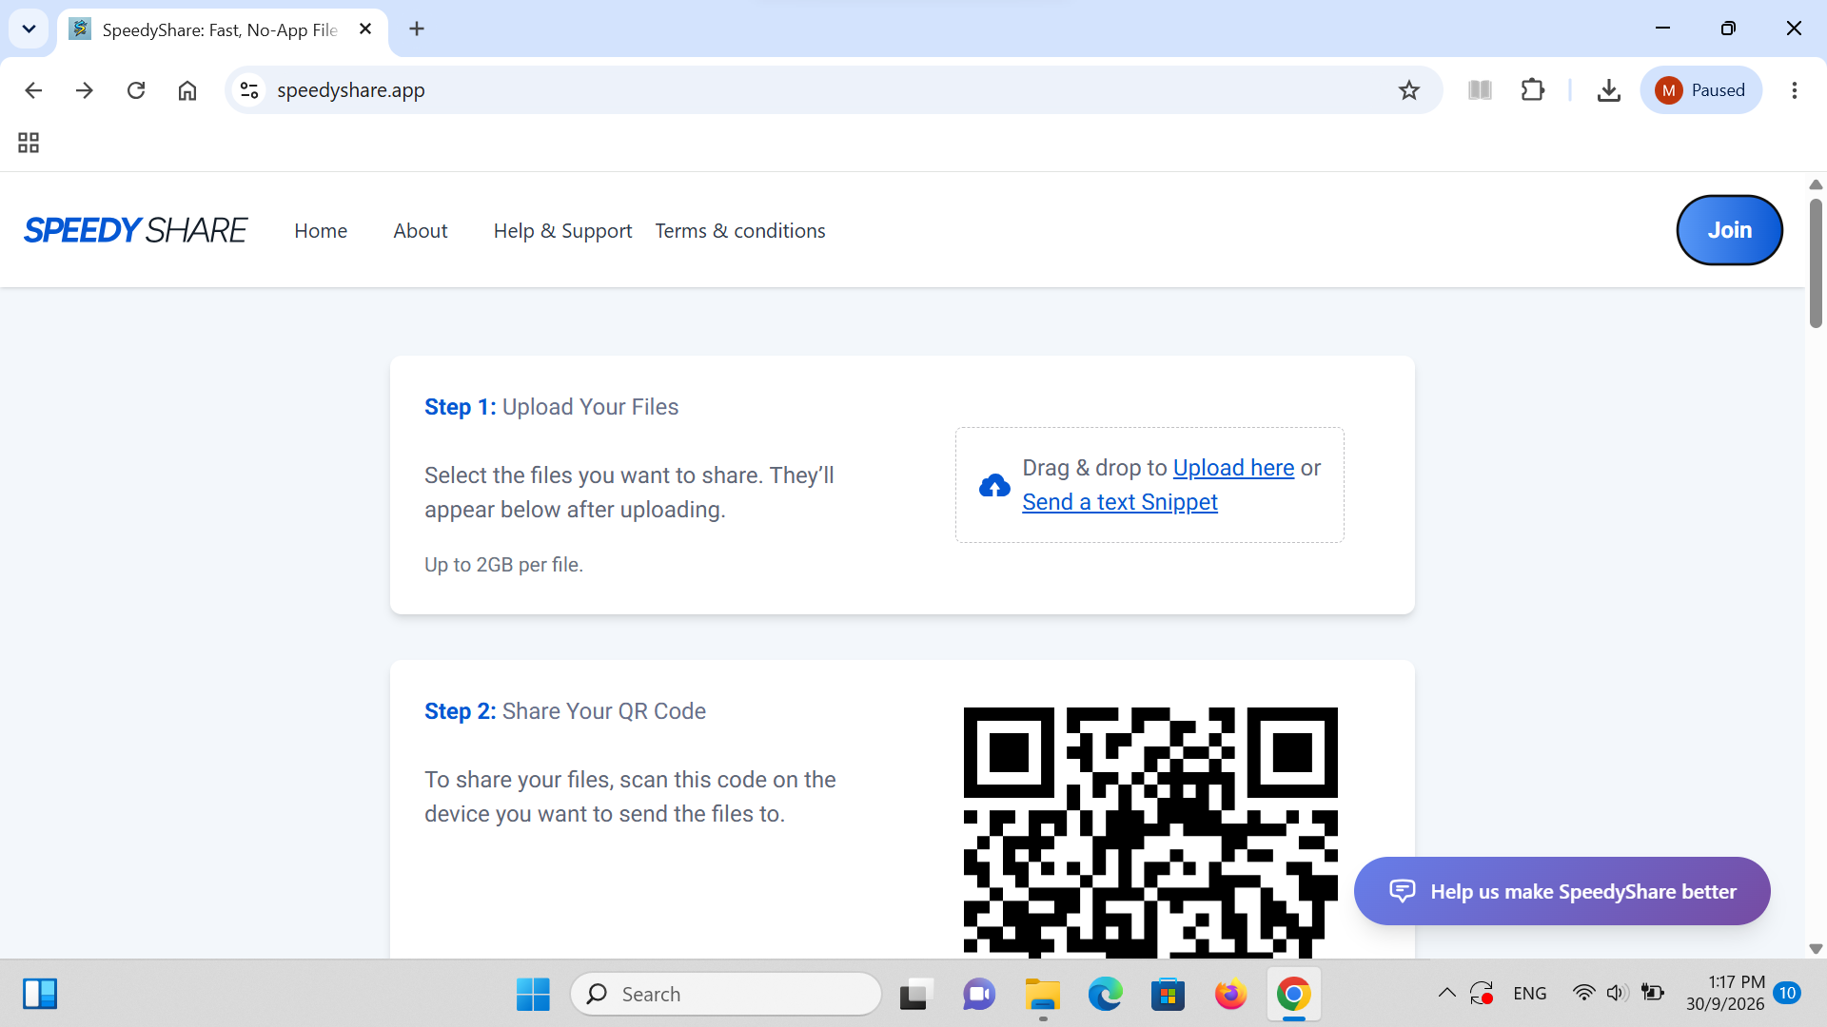
Rajah 9: on student's laptop, open speedyshare and click join.png
Langkah 10: Enter Teacher's 6-Digit Share Code
On the 'Enter your Share code' prompt, type the 6-digit code shown on the teacher's screen (e.g. 257575) into the box, then click the blue 'Submit' button.
💡 TIP TEKNIKAL: The code connects the student browser directly to the teacher's upload session without requiring any login or account creation.

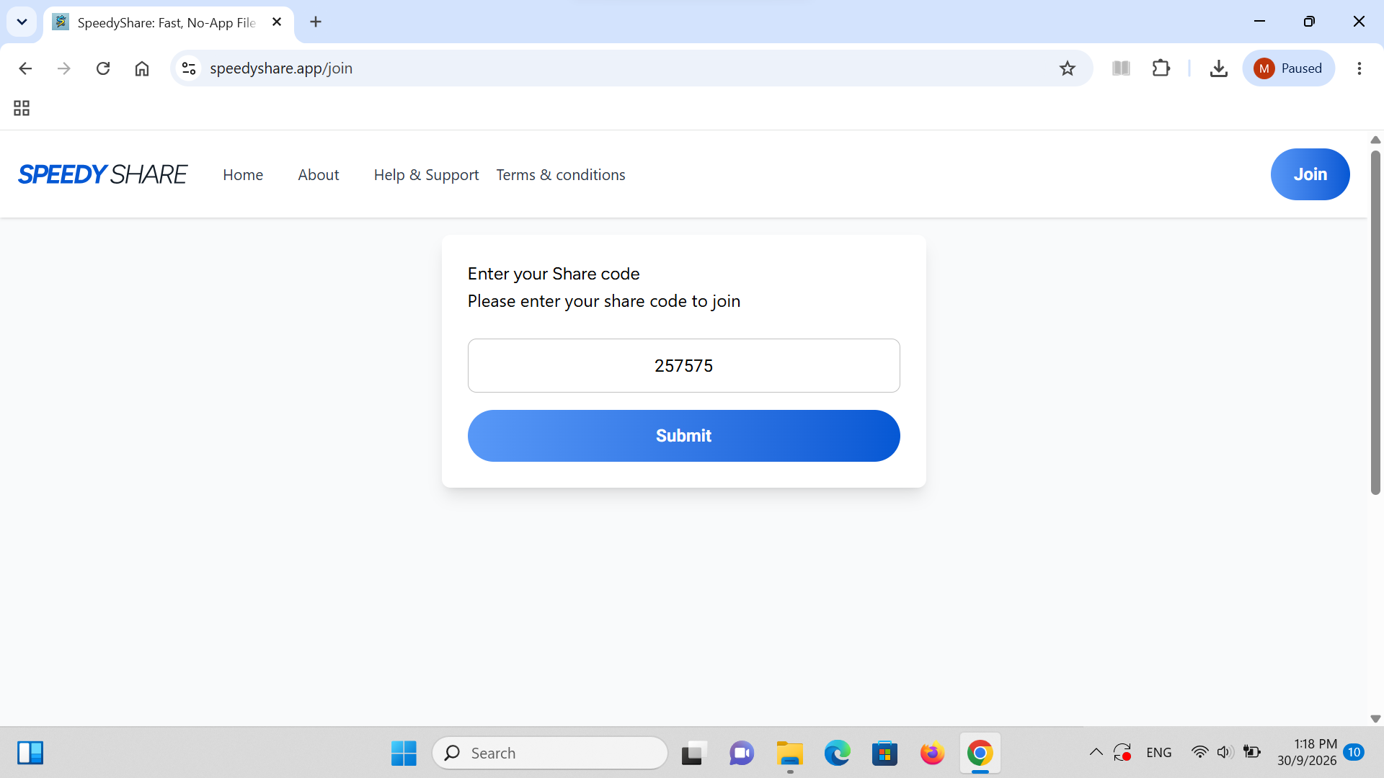
Rajah 10: type in the code from teacher's laptop.png
Langkah 11: Click 'Download all (3)' to Retrieve Package
The 3 shared files will appear on screen. Click the blue 'Download all (3)' button. A single compressed zip file named speedyshare-257575.zip will be saved to the student's Downloads folder.
💡 TIP TEKNIKAL: Downloading as a single zip archive ensures all 3 files (installer, public key, firewall script) remain grouped together.

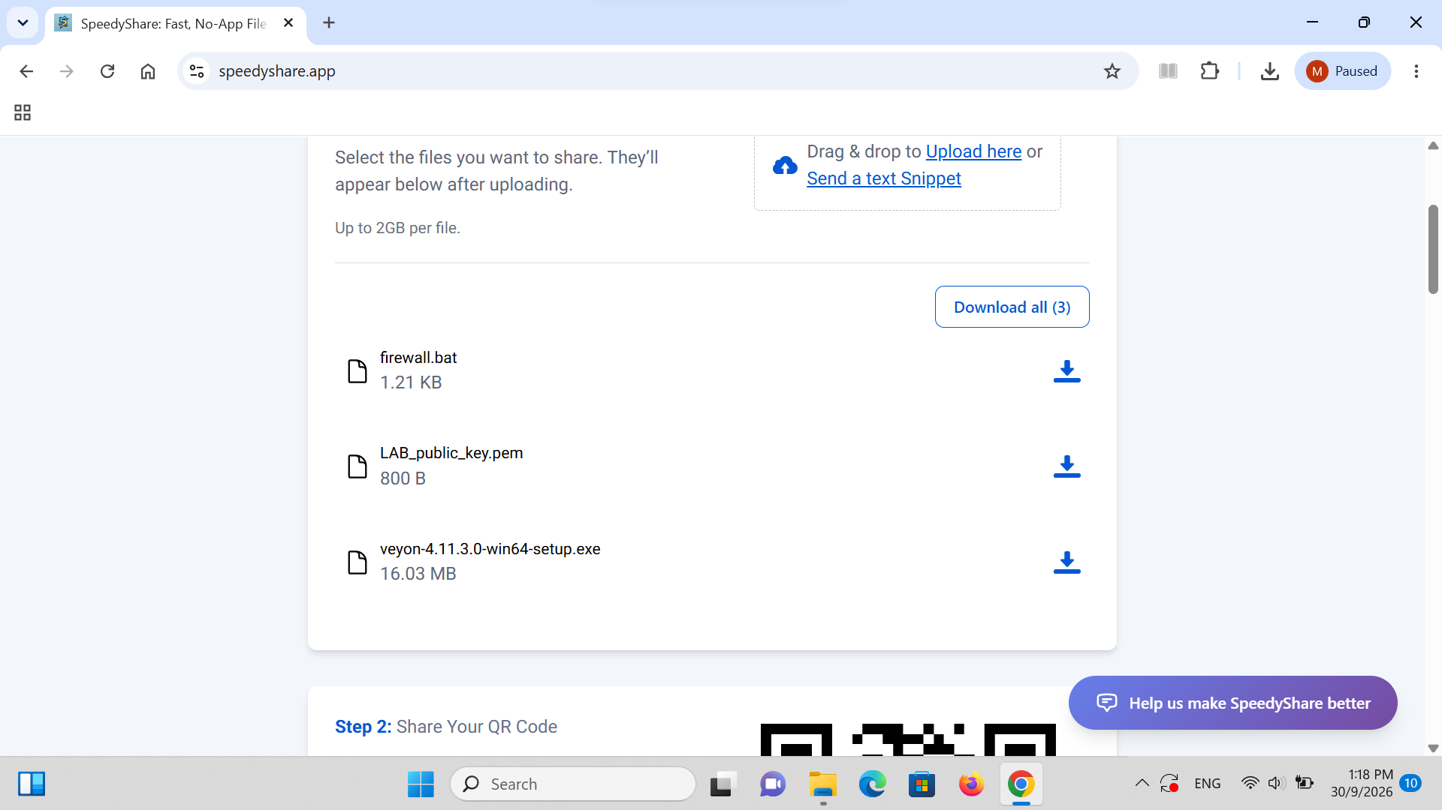
Rajah 11: click download all.png
Langkah 12: Extract the Downloaded Zip Archive
Open File Explorer and navigate to Downloads.
1. Right-click speedyshare-257575.zip.
2. Click 'Extract All...'.
3. Click Extract. This creates an uncompressed folder containing all 3 files.
💡 TIP TEKNIKAL: Always extract before installing so Windows can execute scripts and load the public key cleanly without permission errors.

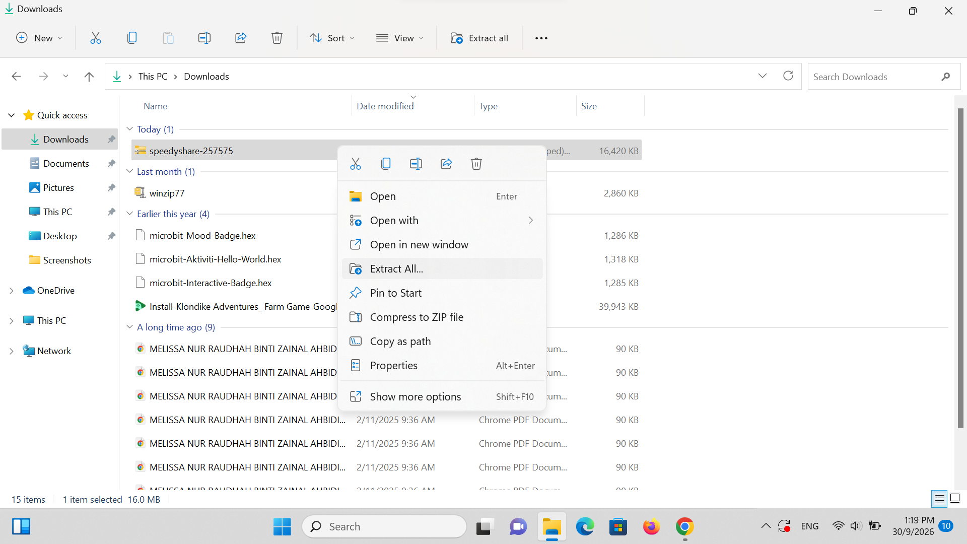
Rajah 12: extract the downloaded files.png
Langkah 13: Launch Installer & Bypass Windows SmartScreen
Inside the extracted folder, double-click veyon-4.11.3.0-win64-setup.exe.
1. When the blue Windows Defender SmartScreen banner appears stating 'Windows protected your PC', click the small underlined 'More info' link.
2. Click the 'Run anyway' button that appears at the bottom.
💡 TIP TEKNIKAL: SmartScreen displays this alert for all downloaded open-source installer binaries. It is safe and normal. Click More info -> Run anyway to proceed.

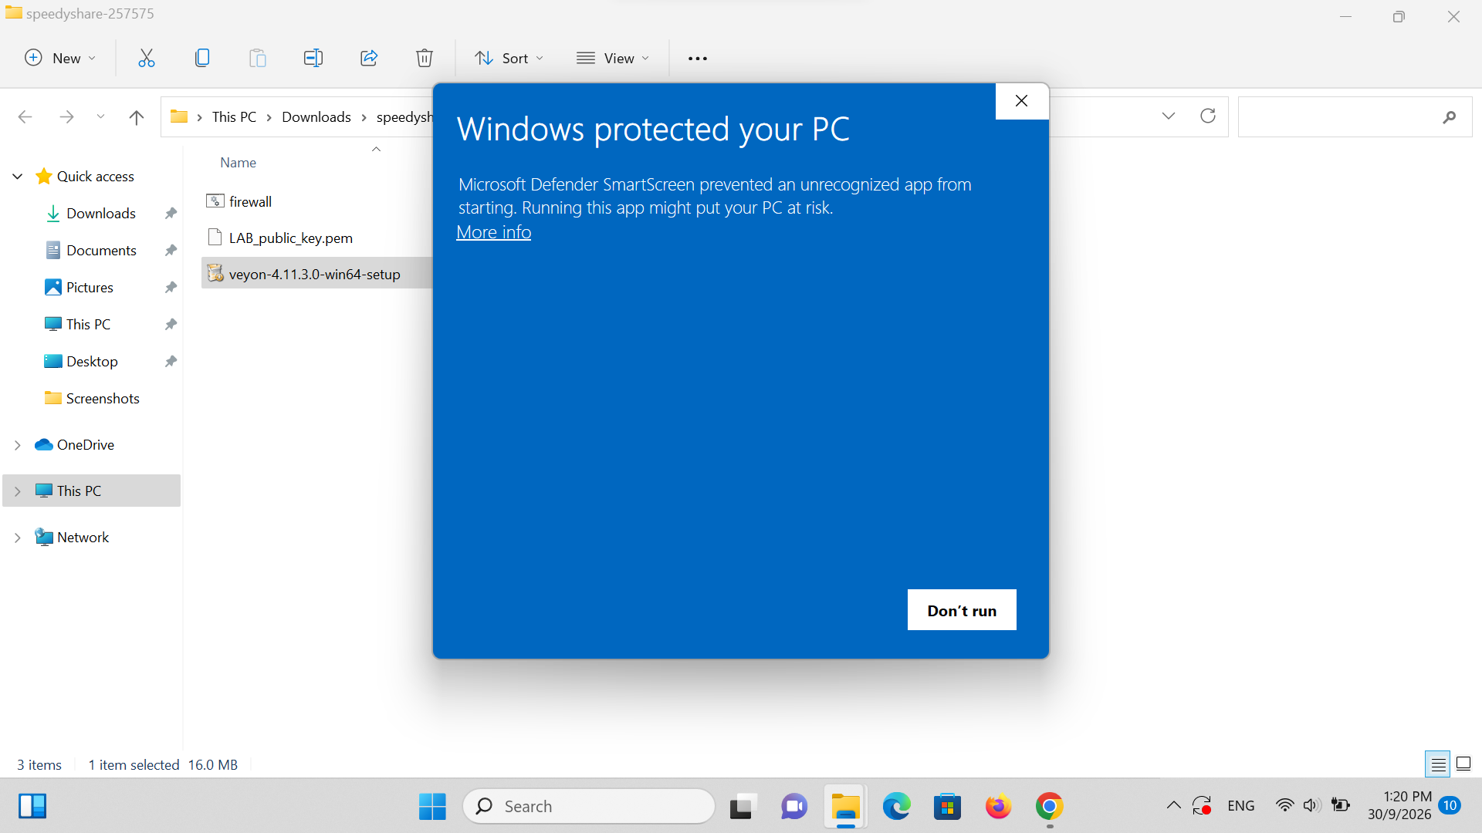
Rajah 13: run veyon configurator, click more info and click run anyway.png
Langkah 14: CRITICAL: UNCHECK 'Veyon Master' on Student Laptop
On the 'Choose Components' setup screen:
• [✓] Veyon Service (KEEP CHECKED)
• [ ] Veyon Master -> 🚨 UNCHECK THIS BOX!
• [✓] Interception driver (KEEP CHECKED)
Click Install, then click Finish (ensure 'Run Veyon Configurator now' is checked).
🚨 CRITICAL ANTI-TAMPER RULE: NEVER install Veyon Master on student machines! Students must only have the Veyon Service (background client). If Master is installed, students could open the monitoring console and snoop on their peers.

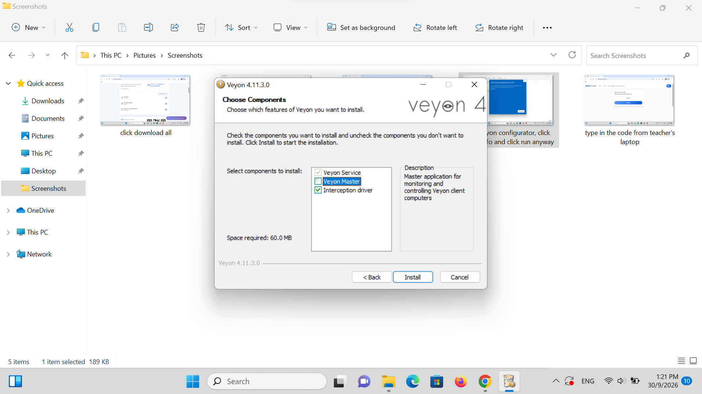
Rajah 14: uncheck veyon master before installing.png
Langkah 15: Configure Student Authentication & Builtin Backend
In Veyon Configurator (Light Theme):
1. Select the 'General' tab.
2. Under 'Authentication', set Method to: 'Key file authentication'.
3. Under 'Network object directory', set Backend to: 'Builtin (computers and locations in local configuration)'.
💡 TIP TEKNIKAL: Notice the student Configurator has a white/light theme with blue highlights, whereas the teacher's machine has dark purple accents.

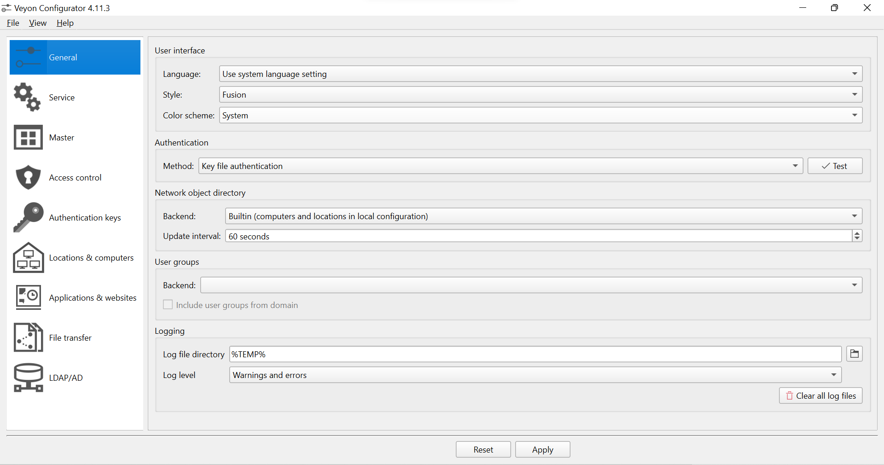
Rajah 15: auth method set to key and backend set to built in.png
Langkah 16: Set Student Service Session Mode to Active
Click the 'Service' tab in the left sidebar.
1. Verify that 'State' shows Running.
2. Under 'Session mode', select 'Active session mode (single server instance for active local or remote session)'.
💡 TIP TEKNIKAL: Active session mode allows Veyon Service to capture whichever student logs in, whether student account, guest, or school KPM domain login.

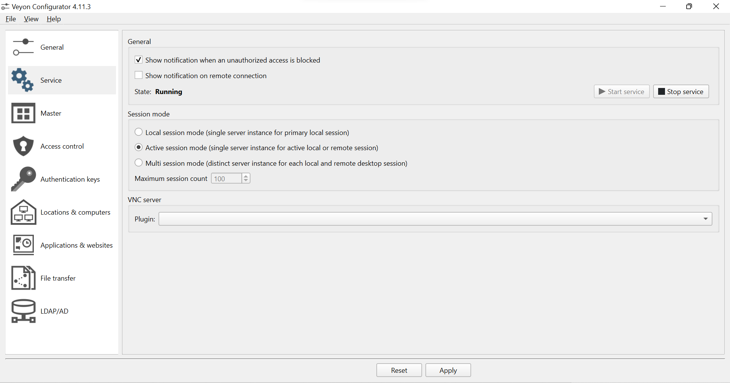
Rajah 16: session mode set to active.png
Langkah 17: Import Teacher's Public Key & Click 'Apply'
Click the 'Authentication keys' tab in the left sidebar.
1. Click the 'Import key' button on the right.
2. Browse into the extracted speedyshare-257575 folder and select 'LAB_public_key.pem'.
3. Click Open. The key 'LAB (public)' will appear in the key list.
4. 🚨 MANDATORY STEP: Click the 'Apply' button at the bottom of the window to commit changes and restart the Veyon Service. Then close Configurator.
🚨 TRAP TO AVOID: If you do not click 'Apply', Veyon will not save the key to Windows registry and the background service will not restart. Always click Apply!

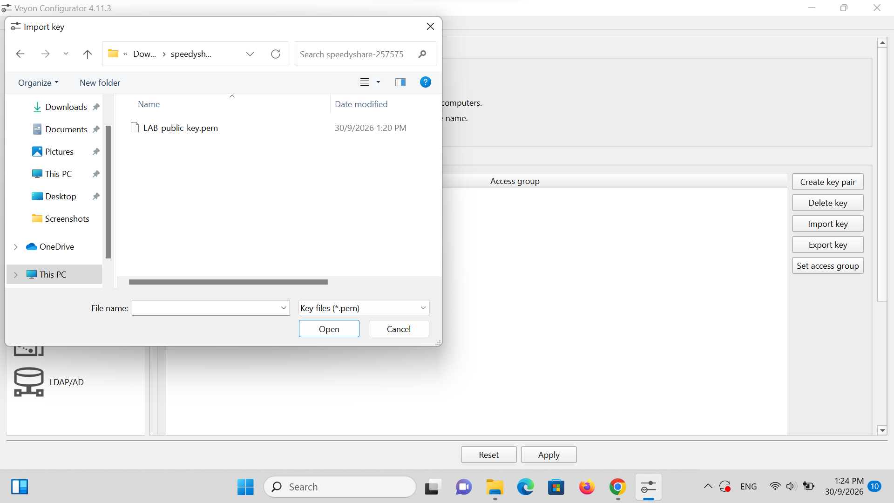
Rajah 17: import public key from the downloaded folder into veyon.png
Langkah 18: Open Windows Terminal or Command Prompt
Press the Windows Start button or tap the Windows key.
1. Type 'terminal' (or 'cmd' / 'command prompt').
2. Click Terminal to open the command line console.
💡 TIP TEKNIKAL: You need the command line to check this laptop's local IPv4 network address.

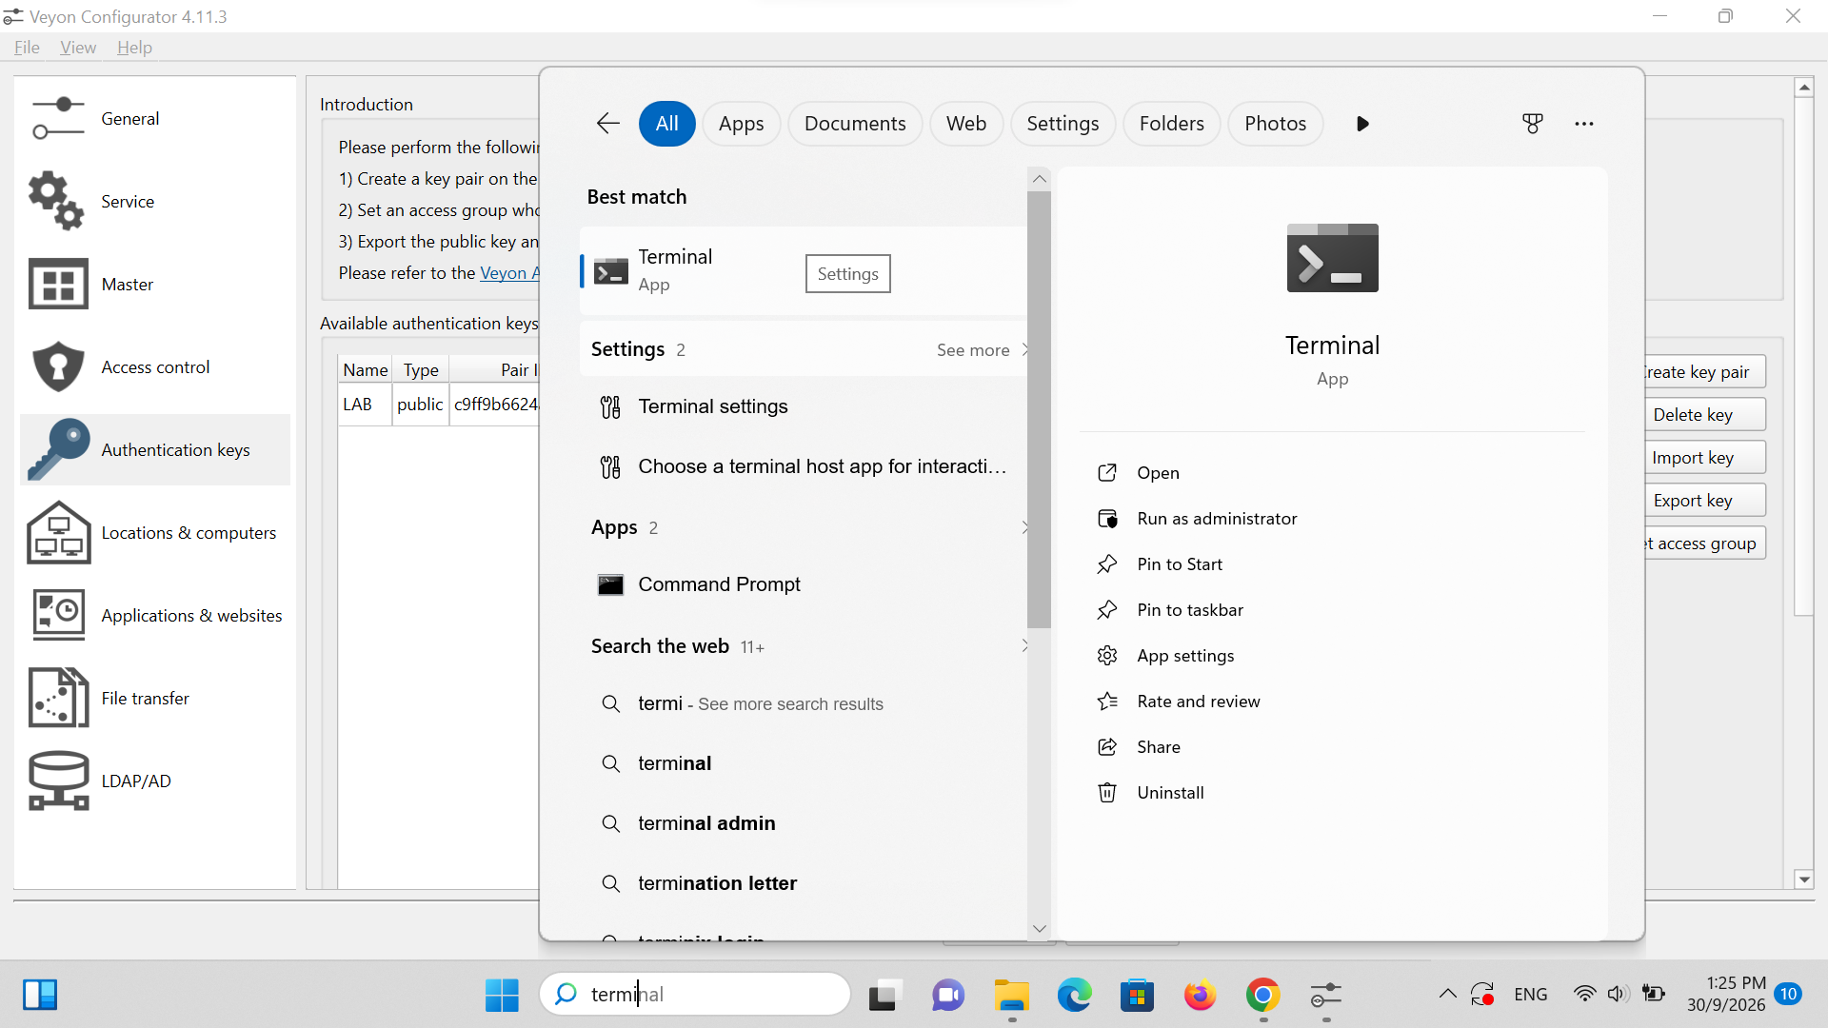
Rajah 18: open terminal.png
Langkah 19: Run ipconfig & Record IPv4 Address with Laptop Label
In the terminal window, type 'ipconfig' and press Enter.
1. Scroll to the active Wi-Fi section ('Wireless LAN adapter Wi-Fi').
2. Note the 'IPv4 Address' (e.g. 192.168.0.166).
3. Check the physical sticker or number label on the laptop (e.g. Computer 17).
4. Write this pair down on a notepad: e.g. 'Computer 17 = 192.168.0.166'.
💡 TIP TEKNIKAL: NETWORK PRO-TIP: If your school router uses dynamic DHCP without IP reservation, IPs might change after a reboot. You can also type 'hostname' in the terminal to jot down the computer's host name (e.g. MAKMAL-17), which remains permanent!

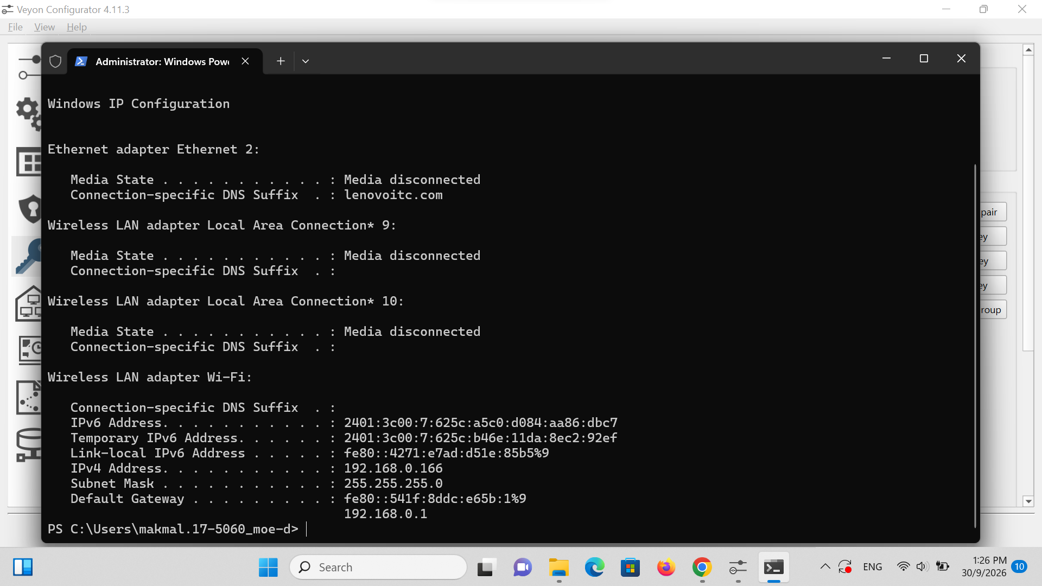
Rajah 19: type in ipconfig and jot down the ip address on a piece of paper alongside the laptop's label number.png
Langkah 20: Run firewall.bat as Administrator
Go back to the extracted speedyshare-257575 folder in File Explorer.
1. Right-click on 'firewall.bat'.
2. Click 'Run as administrator'.
3. Click 'Yes' on the User Account Control (UAC) security prompt.
4. A black console window will flash briefly and close.
💡 TIP TEKNIKAL: This batch script configures Windows Defender Firewall to allow inbound connections on Veyon ports (11100, 11200, 11300, 11400). Without this, the student laptop will appear permanently offline on the teacher's screen.

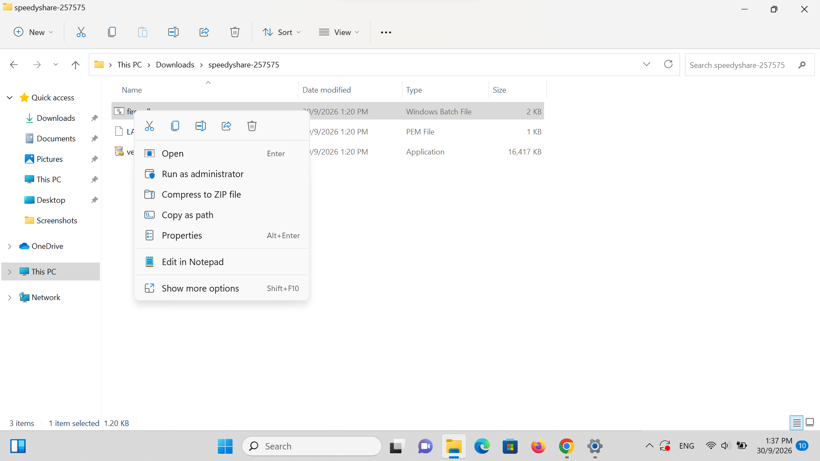
Rajah 20: on student's laptop, run firewall bat as administrator.png

PHASE 3: TEACHER COMPUTER PAIRING & LIVE MONITORING
Lokasi / Stesen: TEACHER PC (GURU) | Tema: Dark Theme (Purple)

🚨 STOP & CHECK: Before doing this step, make sure you have repeated Steps 9 through 20 across all student laptops and gathered your complete list of IP addresses on your notepad!

Langkah 21: Return to Teacher PC: Add Classroom Lab Location
Return to the Teacher laptop. Open Veyon Configurator.
1. Click the 'Locations & computers' tab in the left sidebar.
2. Under the 'Locations' panel on the left, click the '+' button at the bottom.
3. Type your lab location name, such as 'LAB' (or 'MAKMAL').
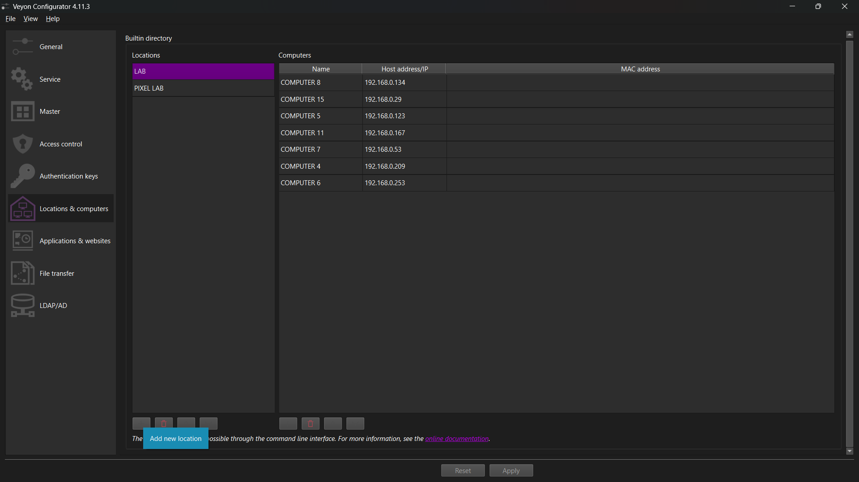
Rajah 21: back on teacher's device, add new location.png
Langkah 22: Add Student Computer Entry under Location
With your location ('LAB') highlighted on the left:
1. Click the '+' button at the bottom of the 'Computers' panel on the right.
2. In the 'Name' column, enter the computer label from your notes (e.g. 'COMPUTER 17').
💡 TIP TEKNIKAL: Naming computers to match their physical lab desk stickers (e.g. COMPUTER 1, COMPUTER 2, etc.) makes it effortless to spot which student is off-task during class.

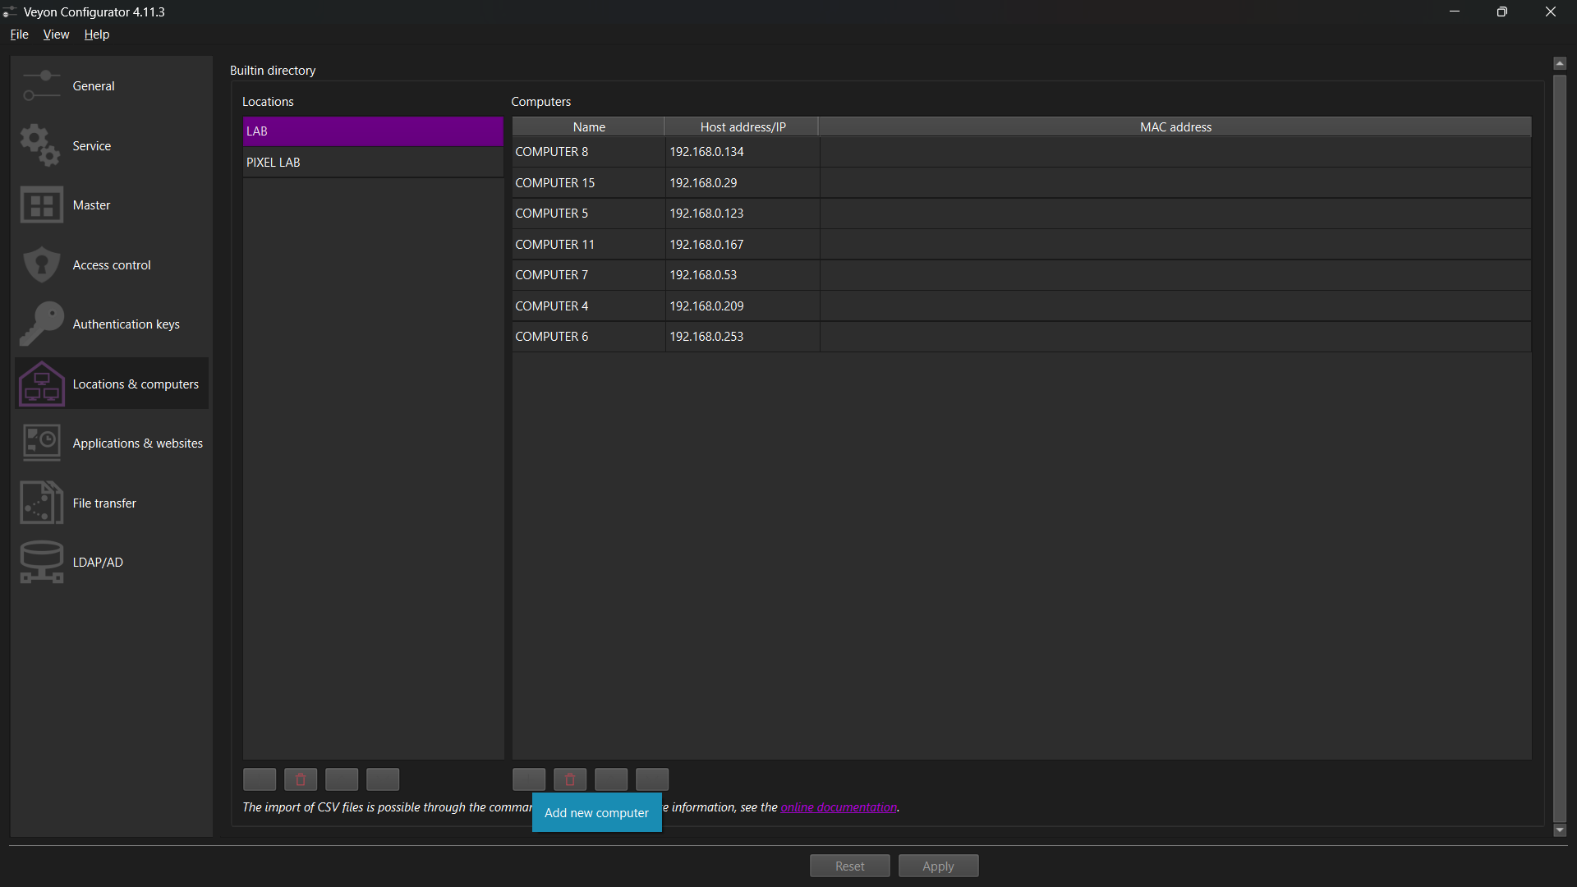
Rajah 22: add new computer and name it with the label such as computer 17.png
Langkah 23: Assign Recorded IP Address & Click 'Apply'
In the 'Computers' table:
1. Double-click the 'Host address/IP' column next to 'COMPUTER 17'.
2. Type in the recorded IPv4 address (e.g. 192.168.0.166).
3. Repeat adding rows for all other student computers from your notepad.
4. Click the 'Apply' button at the bottom to save your configuration. Close Veyon Configurator.
💡 TIP TEKNIKAL: You can also type the computer's hostname if your school router supports local DNS resolution.

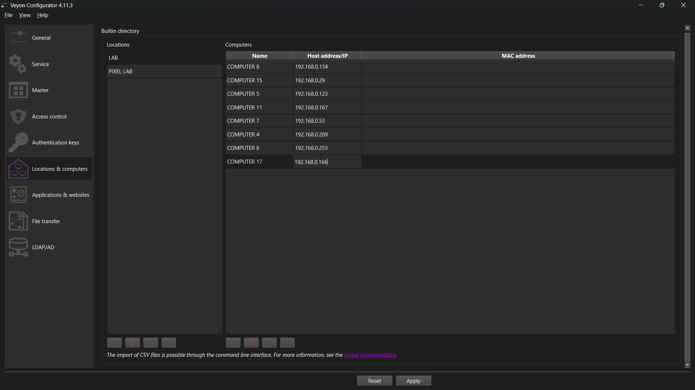
Rajah 23: type in the ip address from the jotted down note and click apply.png
Langkah 24: Launch Veyon Master Application
Open your Windows Start Menu.
1. Search for 'Veyon Master' (the black eye icon with green/pink aura).
2. Click Veyon Master to launch the classroom control console.
💡 TIP TEKNIKAL: You can right-click Veyon Master and select 'Pin to taskbar' for one-click access during daily lessons.

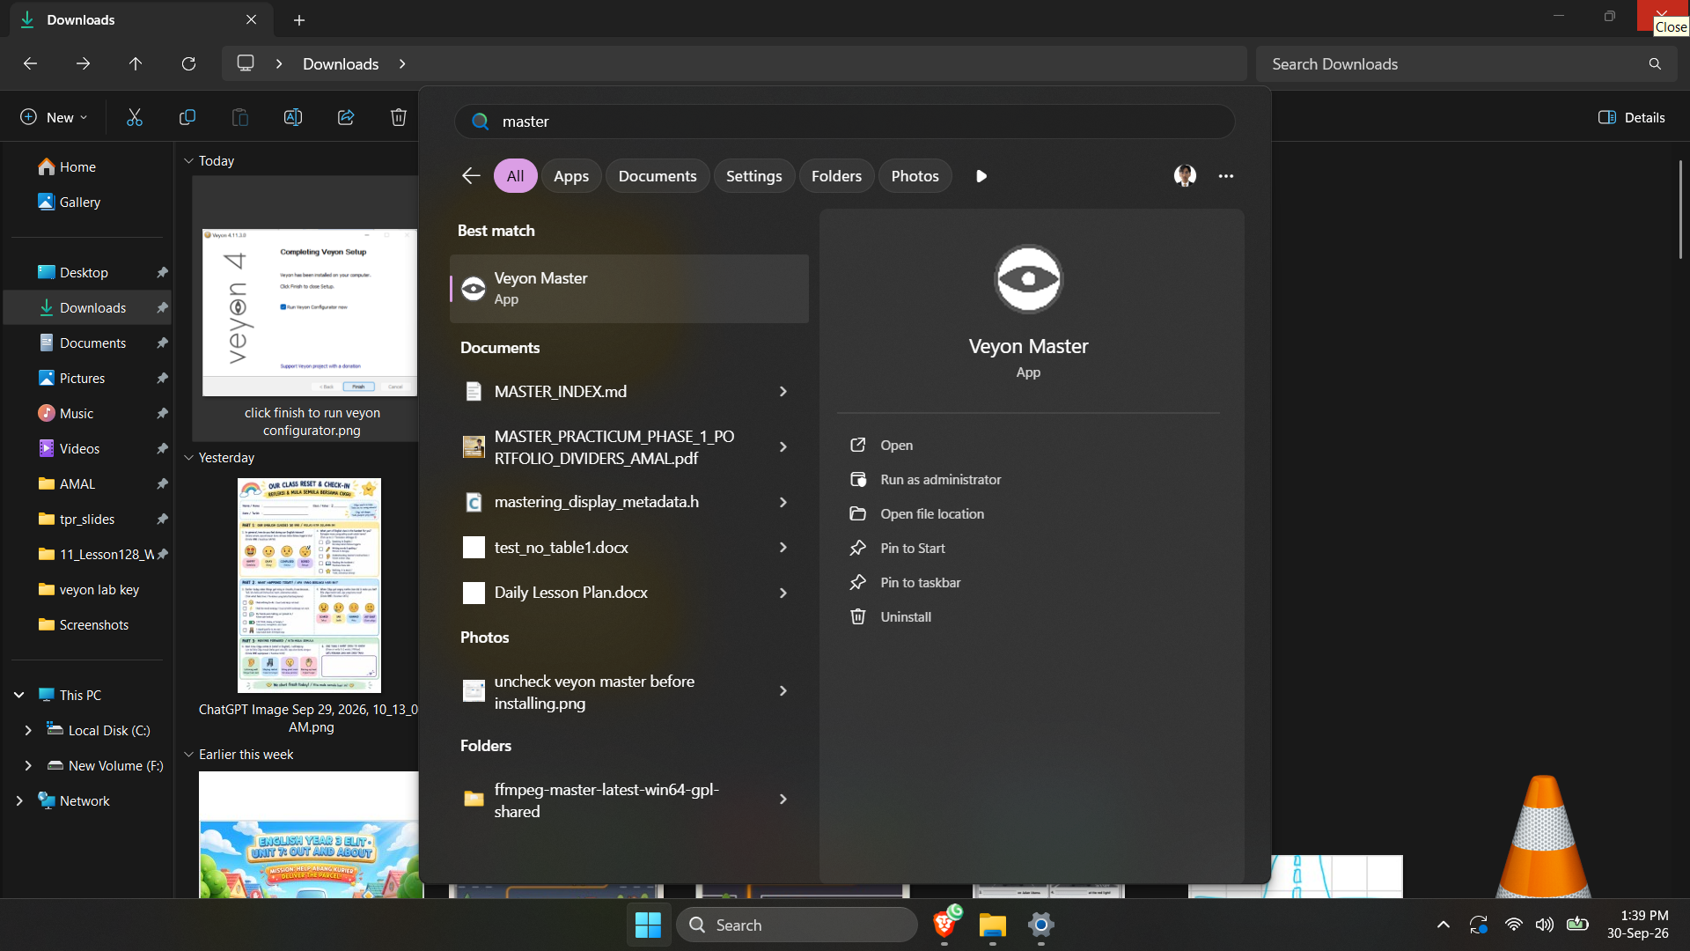
Rajah 24: open veyon master.png
Langkah 25: Toggle 'Locations & computers' Panel in Veyon Master
In the Veyon Master window, look at the bottom-left corner of the screen.
1. Click the 'Locations & computers' button.
2. A sidebar will expand on the left showing your registered locations ('LAB', 'PIXEL LAB').
💡 TIP TEKNIKAL: This sidebar allows you to switch between different computer labs or classes with a single click.

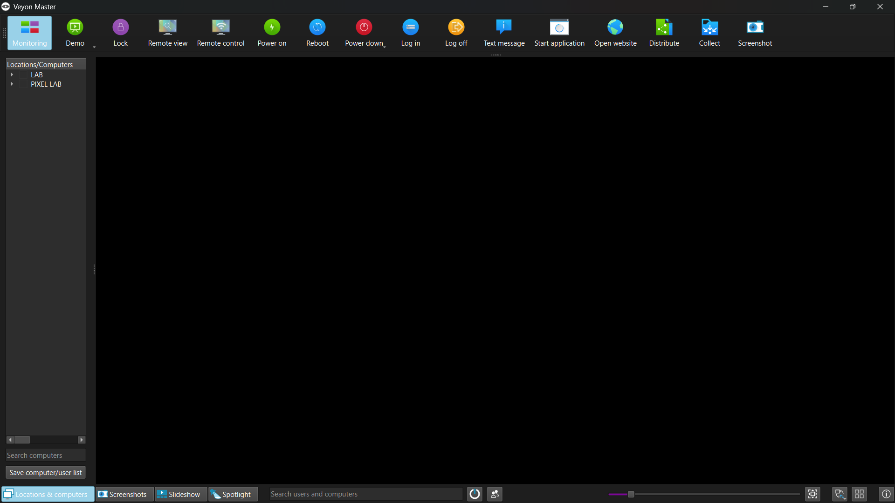
Rajah 25: click location and computers.png

Langkah 26: Tick Location Checkbox & Monitor Live Student Screens!
In the left sidebar under Locations/Computers, tick the checkbox next to your lab: '[✓] LAB'.
• Connected student screens immediately pop up in real-time grid view (e.g. MAKMAL.17-SK DATARAN MUDA KPM-Lab - COMPUTER 17 shows active live desktop!).
• Offline machines appear grayed out until powered on.
💡 TIP TEKNIKAL: TEACHER POWER FEATURES: Double-click any screen thumbnail to view full screen. Use the top toolbar to 'Lock' screens, broadcast your screen ('Demo'), send a 'Text message', or 'Power down' all laptops at the end of class.

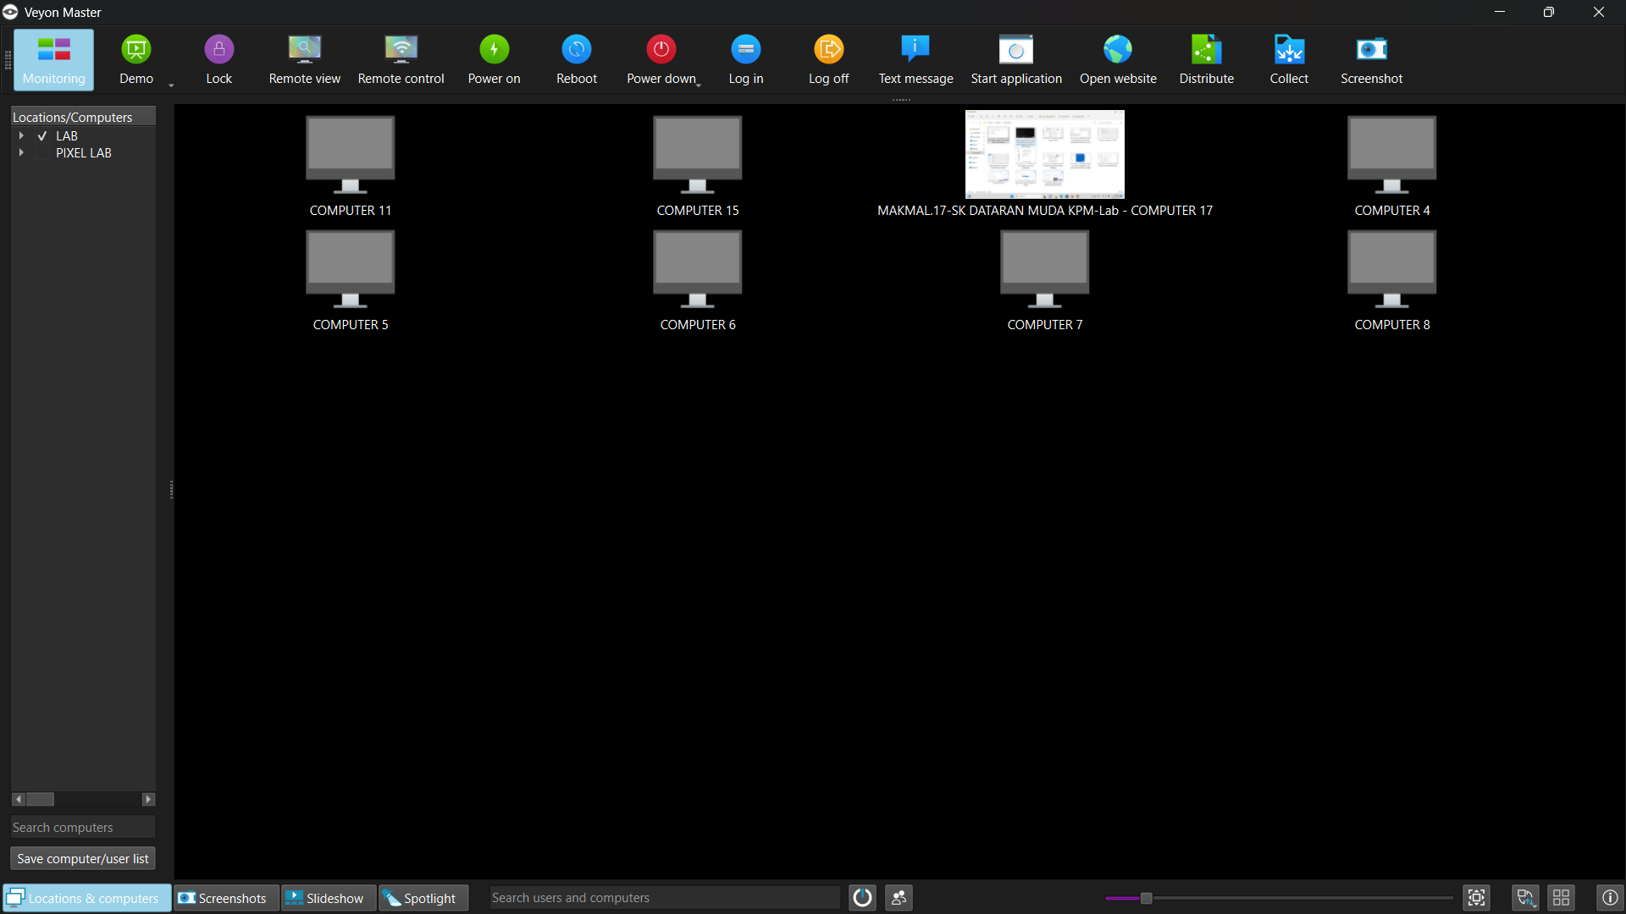
Rajah 26: tick the box of the location you'd like to monitor.png

PANDUAN MENYELESAIKAN MASALAH LAZIM (TROUBLESHOOTING FAQ)

Masalah 1: Skrin komputer murid keluar ikon hitam / 'Host unreachable'.
Penyelesaian:
1. Pastikan kedua-dua komputer guru dan murid bersambung pada Wi-Fi/rangkaian yang sama.
2. Pastikan 'firewall.bat' telah dijalankan sebagai Administrator pada komputer murid (Langkah 20).
3. Semak sama ada IP komputer murid telah bertukar (taip 'ipconfig' semula di terminal murid). Jika bertukar, kemas kini IP dalam Veyon Configurator guru.
Masalah 2: Ralat 'Authentication failed' atau tidak dibenarkan sambung.
Penyelesaian: Pastikan nama pasangan kunci (Key pair) yang diimport pada murid sepadan sepenuhnya dengan nama kunci guru (cth: 'LAB'). Semak tab 'Authentication keys' di komputer murid.
Masalah 3: Murid dapat membuka Veyon Master dan cuba memantau guru.
Penyelesaian: Anda terlupa menyah-tanda (uncheck) 'Veyon Master' semasa pemasangan di komputer murid (Langkah 14). Buka Control Panel -> Uninstall/Change -> Modifikasi Veyon dan nyah-tanda Veyon Master.
Masalah 4: Sambungan SpeedyShare gagal ketika murid cuba menyertai.
Penyelesaian: Pastikan tab pelayar SpeedyShare di komputer guru masih terbuka dan tidak ditutup atau komputer tidak 'sleep' (Langkah 8).
Masalah 5: IP komputer murid sering berubah setiap kali laptop dihidupkan semula (Dynamic DHCP).
Penyelesaian: Gunakan 'Hostname' komputer (taip 'hostname' di terminal, cth: MAKMAL-17) di dalam ruangan 'Host address/IP' di komputer guru, atau tetapkan Static IP / DHCP reservation pada router makmal.

